**FASTAG IMPLEMENTATION**

**Circuit diagram:**

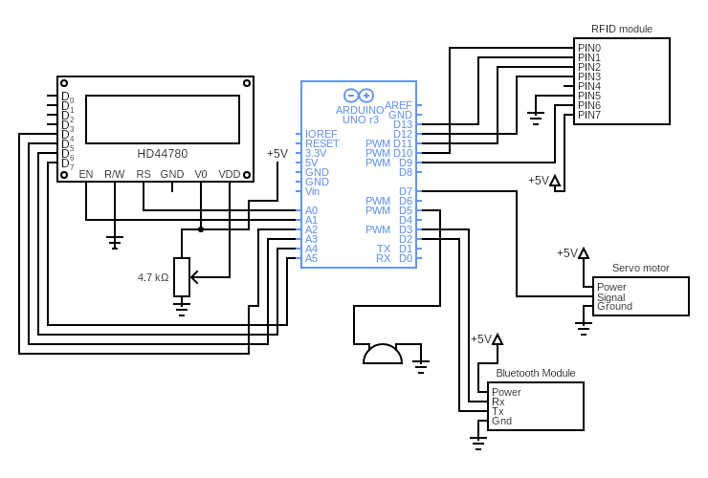

**Working of components**

**Arduino UNO Board:**

The user can get started by connecting the Uno to a computer with the USB cable or by powering it with an AC / DC adapter or battery. The Uno can be programmed with Arduino Software (Integrated Development Environment). Arduino Uno features 14 digital input / output pins (six of which can be used as PWM outputs), six analog inputs, and a 16MHz quartz crystal. Uno also includes a USB connection, a power jack, an In- Circuit Serial Programming (ICSP) header, and a reset button. This Arduino MCU board contains everything the user needs to support the MCU.

**Servo Motor:**

The servo motor is connected to the D2 pin of Arduino. A servo consists of a Motor (DC or AC), a potentiometer, gear assembly, and a controlling circuit. First of all, we use gear assembly to reduce RPM and to increase torque of the motor. Say at initial position of servo motor shaft, the position of the potentiometer knob is such that there is no electrical signal generated at the output port of the potentiometer. Now an electrical signal is given to another input terminal of the error detector amplifier. Now the difference between these two signals, one comes from the potentiometer and another comes from other sources, will be processed in a feedback mechanism and output will be provided in terms of error signal. This error signal acts as the input for motor and motor starts rotating. Now motor shaft is connected with the potentiometer and as the motor rotates so the potentiometer and it will generate a signal. So as the potentiometer’s angular position changes, its output feedback signal changes. After sometime the position of potentiometer reaches at a position that the output of potentiometer is same as external signal provided. At this condition, there will be no output signal from the amplifier to the motor input as there is no difference between external applied signal and the signal generated at potentiometer, and in this situation motor stops rotating.

**Buzzer:**

The buzzer is connected to the D3 pin of Arduino. It consists of an outside case with two pins to attach it to power and ground. Inside is a piezo element, which consists of a central ceramic disc surrounded by a metal (often bronze) vibration disc. When current is applied to the buzzer it causes the ceramic disk to contract or expand. Changing the This then causes the surrounding disc to vibrate. That’s the sound that you hear. By changing the frequency of the buzzer, the speed of the vibration’s changes, which changes the pitch of the resulting sound.

**RFID reader module:**

The RFID module makes total 7 connections with Arduino, including the power and ground. The pins that are used here to connect the module are, D9, D10, D11, D12 and D13. A RFID reader stays powered on all the time and is normally powered from an external power source. So, when it is ON, the oscillator in it generates a signal with a desired frequency but as the signal strength will be very less (which may lead to fading off the signal if it is transmitted directly) it has to be amplified which can be done using an amplifier circuit, in order to propagate the signal to a longer distance we need to modulate the signal which is done by a modulator. With all these improvements the signal is now ready to be transmitted which can be done by an antenna which converts the electrical signal into an electromagnetic signal.The RFID reader signals are everywhere with its probity to detect a tag. When a RFID tag comes in the proximity of the RFID reader the tag detects the readers signal through a coil present in it which converts the received RF signal into an electrical signal. This converted signal alone is sufficient to power up the microchip present in the tag. Once the microchip gets powered up, its function is to send the data (unique ID) which it is stored in it. The same way the signal came in, it is sent out through the same coil into the air.

As discussed earlier the RFID reader also has a transceiver in it. When the signal comes back from the tag through the antenna of RFID reader it is fed to the demodulator and then decoded by a decoder where the original data can be obtained and then further processed by a microcontroller or a microprocessor to perform a specific task.

**16x2 LCD:**

The LCD module is in connection with D8 to D13 pins of Arduino. An LCD (Liquid Crystal Display) screen is an electronic display module and has a wide range of applications. A 16x2 LCD display is very basic module and is very commonly used in various devices and circuits. A 16x2 LCD means it can display 16 characters per line and there are 2 such lines. In this LCD each character is displayed in 5x7 pixel matrix. The 16 x 2 intelligent alphanumeric dot matrix display is capable of displaying 224 different characters and symbols. This LCD has two registers, namely, Command and Data.

Command registers stores various commands given to the display. Data register stores data to be displayed. The process of controlling the display involves putting the data that form the image of what you want to display into the data registers, then putting instructions in the instruction register. In your Arduino project Liquid Crystal Library simplifies this for you so you don't need to know the low-level instructions. Contrast of the display can be adjusted by adjusting the potentiometer to be connected across VEE pin.

**HC-05 Bluetooth Module:**

The Bluetooth standard, like WiFi, uses the FHSS technique (Frequency-Hopping Spread Spectrum), which involves splitting the frequency band of 2.402-2.480 GHz into 79 channels (called hops), each 1MHz wide. Then it transmits the signal using a sequence of channels known to both the sending and receiving stations. Thus, by switching channels as often as 1600 times a second, the Bluetooth standard can avoid interference with other radio signals.

The Bluetooth standard is based upon a master/slave operational mode. The term piconet is used to refer to the network formed by one device and all devices found within its range. Up to 10 piconets can coexist within a single coverage area. A master can simultaneously connect to up to 7 active slave devices (255 when in parked mode). Devices in a piconet have a logical address of 3 bits, for a maximum of 8 devices. Devices in parked mode are synchronized, but do not have their own physical address in the piconet.In reality, at a given moment, the master device can only be connected to a single slave at once. Therefore, it quickly switches between slaves in order to make it seem as if it is simultaneously connected to all the slave devices. Bluetooth enables two piconets to be linked to one another in order to form a wider network, called a scatternet, using certain devices which act as a bridge between the two piconets.

HC-05 Bluetooth Module is an easy-to-use Bluetooth SPP (Serial Port Protocol) module, designed for transparent wireless serial connection setup. Its communication is via serial communication which makes an easy way to interface with controller or PC.